

I. Introduction
A. Contoso’s Marketing Plan
- The purpose of this marketing plan is to outline a comprehensive strategy that will drive the successful promotion, positioning, and growth of our company/product/service in the marketplace.
- This serves as a roadmap, providing a clear direction and set of actionable steps to achieve our marketing objectives and reach our target audience effectively.
- By developing this plan, we aim to create a cohesive and integrated approach to attract, engage, and retain customers, driving business growth and maximizing our competitive advantage.
- The scope of this plan encompasses a thorough analysis of the market landscape, identification of target markets, formulation of key strategies, and allocation of resources, ensuring a well-defined roadmap to guide our marketing efforts.
- Through the implementation of this plan, we aim to strengthen brand awareness, increase market share, and generate meaningful customer interactions, leading to increased customer loyalty and long-term profitability.


B. Company Overview
- Contoso is a leading consulting company that specializes in providing data-driven analytics services to businesses across various industries. With a team of experienced professionals and a focus on leveraging data insights, we empower organizations to make informed and strategic decisions that drive growth, improve efficiency, and maximize profitability.
- Our core objective is to help clients unlock the full potential of their data by applying advanced analytical techniques and innovative technology. Through a combination of consulting expertise and robust data analytics tools, the company assists clients in harnessing the power of data to gain a competitive edge in the market.
- Our consulting services encompass a wide range of areas, including market research, customer segmentation, predictive modeling, performance optimization, and risk assessment. By delving deep into clients' data repositories, we uncover hidden patterns, trends, and insights that can shape critical business strategies and drive success.
- Our approach to consulting revolves around understanding clients' unique business challenges and goals. We collaborate closely with clients to develop tailored solutions that align with their specific needs, ensuring a customized and results-oriented approach. With a focus on practicality and actionable insights, we deliver recommendations that are backed by robust data analysis and supported by industry best practices.



II. Target Market
The target market for Contoso's consulting services can vary depending on the specific industries and sectors they cater to. However, Contoso’s services are relevant and valuable to a wide range of businesses and organizations that operate in data-rich environments. Here are some key segments that may constitute the target market for Contoso:
- Large Enterprises: Contoso's expertise and advanced analytics capabilities make them an ideal partner for large organizations with complex data ecosystems. These enterprises often have extensive data repositories and require sophisticated analytics solutions to gain actionable insights and drive strategic decision-making.
- Mid-sized Companies: Mid-sized companies that have accumulated substantial data and seek to leverage it for business growth can benefit from Contoso's services. These companies may have specific challenges related to data analysis, market segmentation, customer behavior, or performance optimization, and Contoso can provide tailored solutions to address those needs.
- Startups and Growing Businesses: Startups and growing businesses looking to establish a sturdy foundation for data-driven decision-making can find value in Contoso's consulting services. These organizations may need assistance in setting up data infrastructure, implementing analytics frameworks, or utilizing predictive modeling to drive growth and enhance operational efficiency.
- Specific Industries: Contoso may also specialize in serving industries or sectors. For instance, they may focus on finance and banking, healthcare, retail, manufacturing, or any industry where data-driven decision-making plays a crucial role. In such cases, their target market would include businesses within those industries seeking to leverage data analytics for competitive advantage.
- Geographic Considerations: While Contoso's services can be offered globally, their target market may be concentrated in specific geographic regions or markets where there is a demand for data-driven consulting services. This could include local, regional, or international markets based on the company's capabilities and market presence.
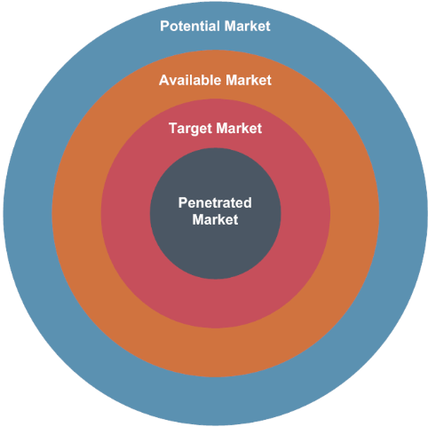
It is important to note that the specific target market for Contoso can be further refined based on their marketing strategy, expertise, and competitive positioning. Conducting market research and analysis would help identify the most promising segments within the broader market that align with Contoso's unique value proposition.

III. Marketing Objectives
- Increase Social Media Engagement: Increase overall social media engagement by 25% within the next six months, as measured by likes, comments, shares, and follower growth, to foster a stronger online community and promote brand awareness and thought leadership.
- Drive Website Traffic: Increase website traffic by 30% within the next quarter through targeted digital marketing efforts, including search engine optimization (SEO), paid advertising, and social media campaigns, to expand brand visibility and generate qualified leads.
- Improve Conversion Rate: Increase the website conversion rate by 15% within the next six months, measured by the percentage of website visitors who take a desired action (e.g., filling out a contact form, downloading a resource), to optimize lead generation and maximize the return on marketing investment.
- Enhance Online Brand Reputation: Improve online brand reputation by actively monitoring and responding to customer feedback, reviews, and mentions across digital platforms, aiming for an average rating of 4.5/5 and maintaining a positive sentiment score of 80% or higher within the next year.
- Expand Target Market Reach: Identify and engage with a new target market segment by launching a targeted social media campaign that reaches a minimum of 10,000 potential clients within the next three months, increasing brand visibility and attracting leads from untapped markets.
- Increase Thought Leadership: Publish a minimum of two thought leadership articles per month on the company blog and secure guest blogging opportunities on reputable industry websites, positioning Contoso as a trusted authority and increasing exposure within the industry.
- Strengthen Digital Partnerships: Establish strategic partnerships with at least two complementary technology providers or industry influencers within the next year, leveraging their online presence and audience to enhance brand visibility and reach new potential clients.
- Optimize Online Advertising ROI: Improve the return on investment (ROI) of online advertising campaigns by implementing data-driven targeting and optimization strategies, aiming for a minimum 20% increase in conversion rates and a 15% decrease in cost per acquisition (CPA) within the next six months.



IV. Marketing Strategies
- Product: Contoso's product offering consists of data-driven analytics consulting services. The marketing plan will focus on highlighting the unique value proposition of these services, emphasizing the expertise, experience, and innovative technology that Contoso brings to the table. This includes highlighting the range of analytics solutions, industry-specific expertise, and customized approaches that differentiate Contoso from competitors.
- Price: The pricing strategy will be determined based on factors such as the complexity of the projects, the scope of services, and the competitive landscape. The marketing plan will outline pricing models, considering options such as project-based fees, retainer models, or subscription-based services. Clear pricing structures and transparent communication will be emphasized to establish trust and ensure clients understand the value they will receive.
- Promotion: The promotion element will involve various strategies to create awareness and generate demand for Contoso's services. The marketing plan will outline a comprehensive digital marketing strategy, including social media campaigns, content marketing, search engine optimization (SEO), targeted advertising, and thought leadership initiatives. The plan will also explore traditional marketing channels like industry events, conferences, and strategic partnerships to expand reach and exposure.
- Place: As a consulting company, the "place" element refers to the channels through which Contoso reaches its target market. The marketing plan will focus on a digital-first approach, leveraging the internet and online platforms to connect with potential clients. This includes a user-friendly and informative website, social media presence on relevant platforms, and online advertising campaigns. The plan may also consider offline channels such as industry-specific publications or direct networking within target industries.
- People: The people element relates to the individuals who interact with clients and deliver the consulting services. In the marketing plan, the focus will be on highlighting the expertise, credentials, and experience of the Contoso team. Testimonials, case studies, and bios of key team members will be included to build trust and credibility with potential clients. Exceptional customer service and client relationship management will also be emphasized to enhance the overall customer experience.
- Process: The process element refers to the streamlined and efficient processes involved in delivering the consulting services. The marketing plan will outline the steps involved in engaging clients, from initial consultation to project execution and post-project follow-up. Clear communication channels, project management systems, and regular reporting will be emphasized to ensure a smooth and transparent process for clients.

V. Budget and Cost Analysis
Total project budget: $200,000
Team Member | Monthly Cost | Project Duration | Total Cost
Project Manager | $8,000 | 6 months | $48,000
Consultant | $6,000 | 6 months | $36,000
Digital Creator | $2,000 | 10 Deliverables | $20,000
Marketing Manager | $10,000 | 6 months | $60,000
Social Media Consultant | $5,000 | 6 months | $30,000
Total |  |  | $194,000

Please note that the "Total" column represents the overall cost for each team member based on their monthly cost or estimated project duration. The total cost for all team members amounts to $194,000, leaving approximately $6,000 for other expenses within the $200,000 budget.



VI. Implementation Plan
- Project Manager:
  - Oversee the entire marketing campaign, ensuring all activities are executed effectively and on time.
  - Coordinate and manage the team members involved in the campaign.
  - Set project goals, milestones, and timelines.
  - Monitor progress, identify potential risks, and implement necessary adjustments.
  - Maintain clear communication with stakeholders and provide regular project updates.
- Consultant:
  - Provide expert guidance and insights on data-driven analytics strategies and solutions.
  - Conduct in-depth analysis of client requirements and develop tailored consulting approaches.
  - Collaborate with the team to develop comprehensive analytics frameworks and methodologies.
  - Deliver high-quality consulting services and recommendations to clients.
  - Monitor industry trends and emerging technologies in the analytics field.
- Digital Creator:
- Create engaging and visually appealing digital content such as graphics, videos, and infographics.
- Develop content for various marketing channels, including social media, website, and advertising campaigns.
- Collaborate with the marketing team to align content with the overall brand messaging and campaign objectives.
- Ensure consistency in visual branding and adherence to brand guidelines.
- Stay updated on design trends and best practices in digital content creation.
- Marketing Manager:
- Develop and execute the overall marketing strategy for Contoso.
- Conduct market research and competitor analysis to identify target markets and key opportunities.
- Develop and manage marketing campaigns across digital, social media, and traditional marketing channels.
- Monitor and analyze campaign performance metrics and make data-driven decisions for optimization.
- Collaborate with cross-functional teams, including sales, product development, and client services, to ensure alignment and achieve business objectives.
- Social Media Consultant:
  - Develop strategies to increase brand awareness, engagement, and lead generation through social media campaigns.
  - Create and curate content for social media platforms, ensuring it aligns with the brand voice and resonates with the target audience.
  - Monitor social media, respond to customer questions, and engage with the online community.
  - Analyze social media metrics and provide insights to optimize campaign performance.
  - Stay updated on social media trends, platform algorithms, and emerging best practices.

VII. Evaluation
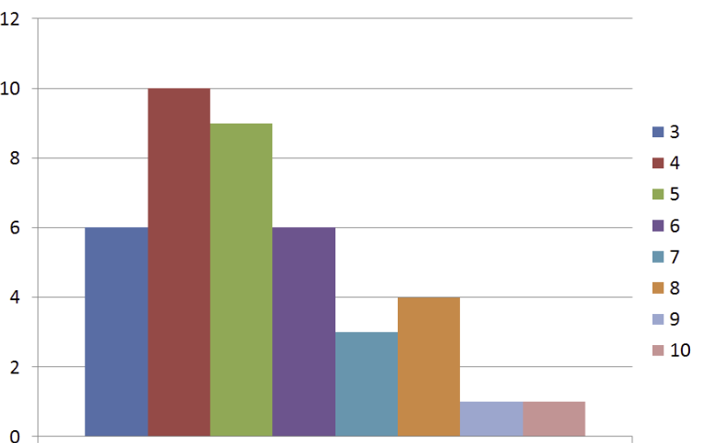
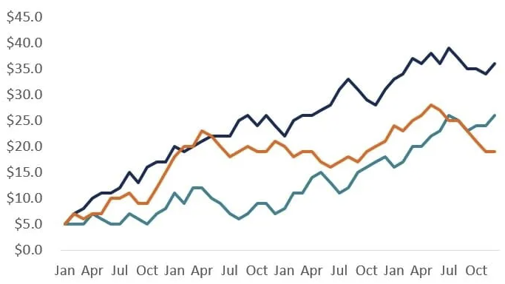

VIII. Conclusion
In conclusion, Contoso, a data-driven analytics consulting company, has great potential to thrive in the market by leveraging effective marketing strategies. Through the implementation of a well-rounded marketing plan, Contoso can enhance its brand presence, attract clients, and drive business growth.
The marketing plan incorporates various elements of the marketing mix, including product positioning, pricing strategies, promotional activities, channel selection, team expertise, customer experience, and streamlined processes. By carefully considering each element, Contoso can establish a strong foundation for success.
The target market for Contoso comprises businesses across industries seeking data-driven analytics solutions. By identifying their unique needs, the marketing plan can be tailored to resonate with potential clients and effectively communicate the value that Contoso brings.
The marketing objectives outlined in the plan focus on social media campaigns, digital marketing, and internet usage. These objectives are SMART (Specific, Measurable, Achievable, Relevant, and Time-bound), ensuring that they are clear, quantifiable, realistic, and aligned with the overall goals of Contoso. By accomplishing these objectives, Contoso can strengthen its brand awareness, expand its reach, increase thought leadership, and generate qualified leads.
Furthermore, the budget and cost analysis provide an estimate of the financial allocation for team members involved in the marketing campaign. This allocation ensures that the resources are effectively utilized to drive the desired outcomes within the $200,000 budget.
Overall, the marketing plan holds significant potential for Contoso. By implementing the outlined strategies and leveraging its expertise in data-driven analytics, Contoso can make a substantial impact. The plan aims to position Contoso as a trusted and innovative consulting partner, attract a diverse range of clients, foster long-term relationships, and ultimately achieve sustainable growth in the competitive market.
With a focused and well-executed marketing plan, Contoso can effectively differentiate itself, capture market opportunities, and establish itself as a leader in the data-driven analytics consulting industry.

